
Ready to learn
Feeling ok
Focused
Happy
Calm

Green zone

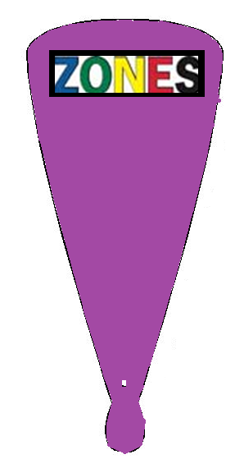
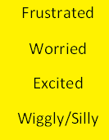

Yellow zone

Moving slow
Sad
Sick
Tired
Bored

Blue zone

Mad
Angry
Mean
Terrified
Yelling
Hitting
Red Zone

