

Policy | Positive Handling
Author | Mel Cork
Adopted by | Governing Board – September 2025
To be reviewed by | September 2026

Contact Details: | Steve Whitfield – Snr Specialist Educational Psychologist.  Email: stephen.whitfield@esset.gov.uk
Mobile: 07827 840763

INDEX

 | Page | Section
Context | 3
Introduction | 3 | 1
Definition of "Restrictive Physical Intervention" | 4 | 2
When the Use of Restrictive Physical Interventions may be Appropriate | 4 | 3
Who May Use Restrictive Physical Intervention | 4 | 3
Planning for the Use of Restrictive Physical Interventions | 5 | 4
Acceptable Forms of Intervention | 6 | 5
Developing and Individual Risk Management Plan and Audited Need | 6 | 6
Guidance and Training for Staff | 7 | 7
Complaints | 7 | 8
Individual Risk Management Plan and Audited need (Form) – identification and assessment of risk | 8 | Appendix 1

Restrictive Physical Intervention in School

School Policy

Essex schools and educational establishments are encouraged to use this framework, and to adapt it to their own situation.
It is advised that all schools should be familiar with the Department for Education ‘Use of reasonable force. Advice for headteachers, staff and governing bodies July 2013’ when considering their own policy on the use of restrictive physical intervention.
Any Policy is best placed within the Rewards and Behaviour Policy; it will be part of a graded response, and needs to be agreed in consultation with staff, governors, parents/carers, and pupils. It also connects to, and should be consistent with, policies on Health and Safety, Child Protection and Safeguarding, Equal Opportunities, and Pastoral Care.

INTRODUCTION
At Heathlands C of E Primary School we believe that pupils need to be safe, to know how to behave, and to know that the adults around them are able to manage them safely and confidently. Only for a very small minority of pupils will the use of physical intervention be needed. On such occasions, acceptable forms of intervention are used.

The majority of pupils behave well and conform to the expectations of our school. We have responsibility to operate an effective relationships and behaviour policy that encompasses preventative strategies for tackling inappropriate behaviour in relation to the whole school, each class, and individual pupils.

All school staff need to feel that they are able to manage inappropriate behaviour, and to have an understanding of what challenging behaviours might be communicating. They need to know what options are available for managing behaviour, and they need to be free of undue worries about the risks of legal action against them if they use appropriate physical intervention. Parents need to know that their children are safe with us, and they need to be properly informed if their child is the subject of a Restrictive Physical Intervention, including the nature of the intervention, and the rationale for its use.

Whenever Restrictive Physical Intervention (or restraint) takes place it is logged on CPOMS with clear details as to the type of hold, timings and which staff were present.

2. DEFINITION OF “RESTRICTIVE PHYSICAL INTERVENTION”

“Restrictive Physical Intervention” is the term used to describe interventions where bodily contact using force is used to control or manage a child’s behaviour. It refers to any instance in which a teacher or other adult authorised by the Headteacher has to use “reasonable force” to control or restrain pupils in circumstances that meet the following legally defined criteria.
- To prevent a child from committing a criminal offence (this applies even if the child is below the age of criminal responsibility)
- To prevent a child from injuring self or others
- To prevent or stop a child from causing serious damage to property (including the child’s own property)
- To stop the child from engaging in any behaviour which is prejudicial to the maintenance of good order and discipline at the school.

There is no legal definition of “reasonable force”. However, there are two relevant considerations:
- the use of force can be regarded as reasonable only if the circumstances of an incident warrant it;
- the degree of force must be in proportion to the circumstances of the incident and the seriousness of the behaviour or consequences it is intended to prevent.
- the intervention must be deemed necessary by all adults involved.

The definition of physical force also includes the use of mechanical devices (e.g. splints on the pupil prescribed by medical colleagues to prevent self-injury), forcible seclusion or use of locked doors. It is important for staff to note that, although no physical contact may be made in the latter situations, this is still regarded as a Restrictive Physical Intervention.

3. WHEN THE USE OF RESTRICTIVE PHYSICAL INTERVENTIONS MAY BE APPROPRIATE AT HEATHLANDS C OF E PRIMARY SCHOOL

Restrictive Physical Interventions will be used when all other strategies have failed, and therefore only as a last resort. However, there are other situations when physical handling may be necessary, for example in a situation of clear danger or extreme urgency. Certain pupils may become distressed, agitated, and out of control, and need calming with a brief Restrictive Physical Intervention that is un-resisted after a few seconds.
The safety and well-being of all staff and pupils are important considerations. Under certain conditions this duty must be an over-riding factor.

WHO MAY USE RESTRICTIVE PHYSICAL INTERVENTION AT HEATHLANDS C OF E PRIMARY SCHOOL
Staff who have successfully undertaken Price training are authorised by the Headteacher to have control of pupils, and must be aware of this Policy and its implications. However, non-inclusion on this list does not mean that an adult is necessarily barred from using physical intervention. If the Head has lawfully placed an adult in charge of children then that adult will be entitled to use restrictive physical intervention.
We take the view that staff should not be expected to put themselves in danger and that removing other pupils and themselves from risky situations may be the right thing to do. We value staff efforts to rectify what can be very difficult situations and in which they exercise their duty of care for the pupils.

Names of Authorised staff
Details of staff who have completed the training are kept on the training log. This is held by the Headteacher.

4. PLANNING FOR THE USE OF RESTRICTIVE PHYSICAL INTERVENTIONS IN HEATHLANDS C OF E PRIMARY SCHOOL

Staff will use the minimum force needed to restore safety and appropriate behaviour.
The principles relating to the intervention are as follows:-
- Restrictive Physical Intervention is an act of care and control, not punishment. It is never used to force compliance with staff instructions.

- Restrictive Physical Intervention will only be used in circumstances when one or more of the legal criteria for its use are met.

- Staff will only use it when there are good grounds for believing that immediate action is necessary and that it is in the pupil’s and/or other pupil’s best interests for staff to intervene physically.

- Staff will take steps in advance to avoid the need for Restrictive Physical Intervention through dialogue and diversion. The pupil will be warned, at their level of understanding, that Restrictive Physical Intervention will be used unless they cease the unacceptable behaviour.

- Only the minimum force necessary will be used.

- Staff will be able to show that the intervention used was a reasonable response incident.

- Every effort will be made to secure the presence of other staff, and these staff may act as assistants and/or witnesses.

- As soon as it is safe, the Restrictive Physical Intervention will be relaxed to allow the pupil to regain self-control.

- A distinction will be maintained between the use of a one-off intervention which is appropriate to a particular circumstance, and the using of it repeatedly as a regular feature of school policy.

- Escalation will be avoided at all costs, especially if it would make the overall situation more destructive and unmanageable.

- The age, understanding, and competence of the individual pupil will always be taken into account.
- In developing Individual Consistent Management Plans, consideration will be given to approaches appropriate to each pupil’s circumstance.
- Procedures are in place, through the pastoral system of the school, for supporting and debriefing pupils and staff after every incident of Restrictive Physical Intervention, as it is essential to safeguard the emotional well-being of all involved at these times

5. ACCEPTABLE FORMS OF INTERVENTION IN HEATHLANDS C OF E PRIMARY SCHOOL

- There are occasions when staff will have cause to have physical contact with pupils for a variety of reasons, for example:

  - to comfort a pupil in distress (use of supportive hug);
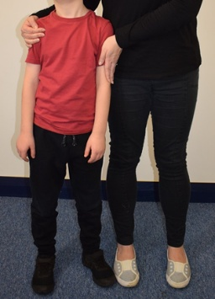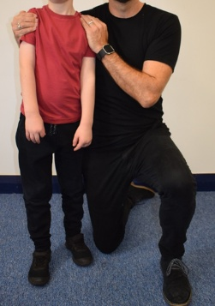
  - to gently direct a pupil (use of ‘offering an arm’ or supportive arm);
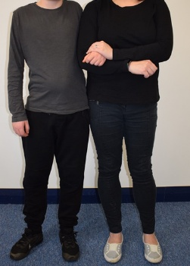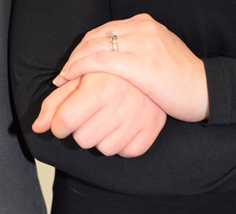
offering an arm
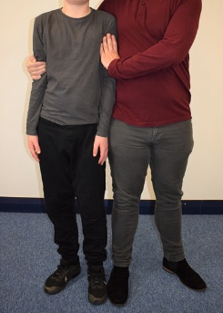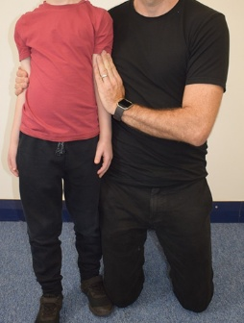
supportive arm
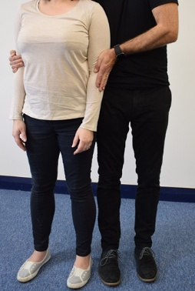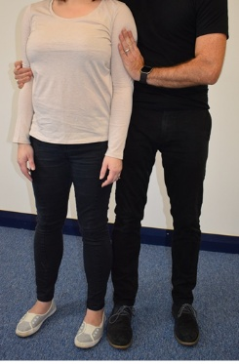
supportive arm

  - for curricular reasons (for example in PE – to support rolls in gymnastics);
  - in an emergency to avert danger to the pupil or pupils
  - In rare circumstances, when Restrictive Physical Intervention is warranted (only staff who have completed Price training);

- In all situations where physical contact between staff and pupils takes place, staff must consider the following:

  - the pupil’s age and level of understanding;
  - the pupil’s individual characteristics and history;
  - the location where the contact takes place (it should not take place in private without others present).

Physical contact is never used as a punishment, or to inflict pain. All forms of corporal punishment are prohibited. Physical contact will not be made with the participants neck, breasts, abdomen, genital area, other sensitive body parts, or to put pressure on joints. It will not become a habit between a member of staff and a particular pupil. [Should a pupil appear to enjoy physical contact this must not be sought via Restrictive Physical Intervention]
6. DEVELOPING AN INDIVIDUAL RISK MANAGEMENT PLAN AND AUDITED NEED IN HEATHLANDS C OF E PRIMARY SCHOOL

If a pupil is identified for whom it is felt that Restrictive Physical Intervention is likely, then an individual risk management plan and audited need form will be completed. This Plan will help the pupil and staff to avoid difficult situations through understanding the factors that influence the behaviour and identifying the early warning signs that indicate foreseeable behaviours that may be developing. The plan will include:
- Involving parents/carers and pupils to ensure they are clear about what specific action the school may take, when and why.
- A risk assessment to ensure staff and others act reasonably, consider the risks, and learn from what happens.
- A record to be kept in school of risk reduction options that have been examined and discounted, as well as those used, using CPOMS.
- Techniques for managing the pupil’s behaviour i.e. strategies to de-escalate a conflict, and stating at which point a Restrictive Physical Intervention may be used.
- Identifying key staff who know exactly what is expected. It is best that these staff are well known to the pupil.
- Ensuring a system to summon additional support.
- Identifying training needs.

[*A school may also need to take medical advice about the safest way to hold a child with specific medical needs.]
See Appendix 1 for the individual risk management plan and audited need pro-forma.

7. GUIDANCE AND TRAINING FOR STAFF
Guidance and training is essential in this area. We need to adopt the best possible practice. In Heathlands C of E Primary school this is arranged for staff at a number of levels including:
- awareness of issues for governors, staff and parents,
- behaviour management techniques for all staff;
- managing conflict in challenging situations - all staff

Training in practical techniques of physical intervention is required for staff where there is a significant likelihood of them needing to intervene physically due to the nature of the pupil (or pupils) that they are working with. Where there is an identified need for such training, staff will be trained by an approved instructor.
(NB: there is no legal requirement for staff to be trained in the use of practical techniques so staff may exercise their legal right to physically intervene even if they have not had such training. However, they would still need to demonstrate that their intervention was reasonable and proportionate.)

8. COMPLAINTS
It is intended that by adopting this policy and keeping parents and governors informed we can avoid the need for complaints. All disputes which arise about the use of force by a member of staff will be dealt with according to Child Protection and Safeguarding policies.

Appendix 1. Individual Risk Management Plan and Audited Need

For assessing and managing foreseeable risks for children who are likely to need Restrictive Physical Intervention.

Name DOB

Position
Physical characteristics (age, height, weight, physical differences, visual or hearing impaired etc)

Risk Factors (medical or emotional conditions, substance misuse, communication differences etc)

Environmental Risk Assessment (where will the student potentially be held, is there risk assessed furniture, floor coverings?)

Staff Matching (are the certain staff who should be present or should not attempt to physically intervene)

Training Needs

Consequences / Limits to freedom (are there restrictions to freedom necessary due to the above)

Individual Risk Management Plan

Unresolved Risk Factors (issues for management)

Risk Assessment Calculator

Name
DOB
Date of Assessment

Harm/Behaviour | Opinion  Evidenced  O/E | Conscious  Sub-conscious  C/S | Seriousness  Of Harm  A  1/2/3/4 | Probability  Of Harm  B  1/2/3/4 | Severity Risk  Score  A x B
Harm to self

Harm to peers

Harm to staff

Damage to property

Harm from disruption

Criminal offence

Harm from absconding
Other harm

Seriousness

4 | Foreseeable outcome is loss of life or permanent disability, emotional trauma requiring counselling or critical property damage
3 | Foreseeable outcome is hospitalisation, significant distress, extensive damage
2 | Foreseeable outcome is harm requiring first aid, distress or minor damage
1 | Foreseeable outcome is upset or disruption
Probability

4 | The risk of harm is persistent and constant
3 | The risk of harm is more likely than not to occur again
2 | The risk of harm has occurred within the last 12 months, the context has changed to make a reoccurrence unlikely
1 | There is evidence of historical risk, but the behaviour has been dormant for over 12 months and no identified triggers remain
Risks which score 6 or more (probability x seriousness) should have strategies listed on next page
Individual Risk Management Plan

Name | DOB | Date | Review Date

Photo | Potential Triggers (PT) & Reduction Measures (RM)  PT –  RM -

What we want to see | Strategies to maintain
First signs that things are not going well | Strategies to support
Where this behaviour leads next | Strategies needed
What we are trying to avoid | Interventions necessary

Signature of Plan Co-ordinator………………………………… Date ……………….

Signature of Parent / Carer……………………………………… Date ………………

Signature of Young Person………………………………………Date……………….
EXAMPLE Record of Restrictive Physical Intervention –FORM ON CPOMS
Student Name: |  |  |  |  | Location of Incident
D.O.B.
 |  |  |  |  | Time and Date of Incident:
Reporting Member of Staff:
Justification for physical intervention  (tick all that apply): |  |  |  |  | Predicted harm prevented by physical intervention with predicted levels ( see Individual Plan)  e.g. bruising to peers, lacerations, destruction of computer, 20 mins of geography lost for 15 pupils etc.)
To prevent harm to self
To prevent harm to other children
To prevent harm to adults
To prevent damage to property
To prevent loss of learning (see plan)
Physical Management Log Complete |  | Y/N |  |  | Name(s) of additional staff witness: | Name(s) of additional student witness:
Accident Book Complete |  | Y/N
Medical Treatment / Injuries |  | Y/N
Damage to Property |  | Y/N
Triggers:
Additional factors:
Unmanaged Harm/ Details of damage to property including costs and details of harm to people including medical intervention:

Management: |  | Comments:
Reparation
Consequences (imposed limits to freedom)
Police involvement
Internal Exclusion / FTEX / PEX
Student response form completed
Student requested further meeting
Review and update of Harm Reduction Plan

Primary de-escalation techniques used
(please state order in which they were used)
Verbal advice and support |  |  | Offering services of other staff
Calm talking |  |  | Informing of consequences
Distraction |  |  | Taking non threatening body position
Reassurance |  |  | Step away
Humour |  |  | Clear instruction / warning
Negotiation |  |  | Use of physical location and presence
Offering choices and options |  |  | Diversion

Restraint techniques including sequence of techniques, time and staff involved:
Time | Technique | Shape |  | Staff Initials
Duration of restraint: |  | Duration of incident:

Student response form completed by: |  |  | Verification of account of incident:
Incident reported to: |  |  |  | Staff name | Staff signature | Date
Parents / Carer informed by: | @
Diary completed by: | @
Student wellbeing verified by: | @
Staff wellbeing verified by: | @
Incident form completed by: | @
Date report completed:

Reporting staff name: ______________________________________ Date: ______________________

Signature: _____________________________________________________________________________

Incident form coordinator/SMT check name: __________________________________________________

Signature: ________________________________________________ Date: _____________________

.

