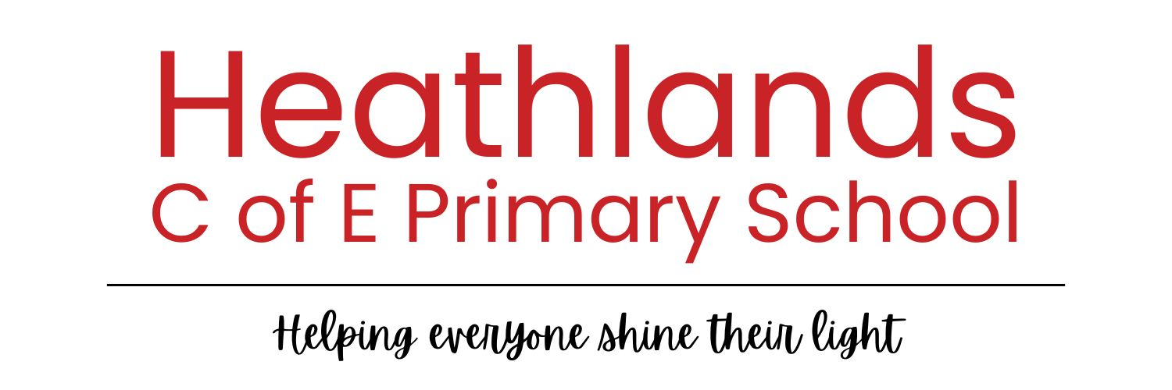

Policy | RE POLICY
Author | Mel Cork
Adopted by | Governing Board – October 2026
To be reviewed by | October 2027
This document is based on a model policy - Life

Our Religious Education Curriculum is of great importance. It will help educate for dignity and respect encouraging all our pupils to live well together.

In line with Section 2 79 (1) School Standards and Framework Act, our RE Curriculum ‘promotes the spiritual, moral, cultural, mental and physical development of pupils and of society, and prepares pupils for the opportunities, responsibilities and experiences of later life’.

The curriculum offers our pupils broad and rich topic coverage, spanning over several of the main world religions whilst also allowing them the opportunity to learn that there are those who do not hold religious beliefs. Alongside religion, children learn about the importance of spirituality and its links across both the curriculum, and their own lives.

Our Curriculum aims to support pupils to become religiously literate; it provides opportunities for pupils to develop positive attitudes and values and to reflect and relate their learning in RE to their own experience.

Through each unit, children will learn about and understand a range of religions and world views (including non-faith world views). They will learn through creative, enquiry-based, theological, philosophical and human and social science approaches.

The children will study religions via in-depth studies and encounters, regularly applying their knowledge to current affairs and real-world issues. Overall, our curriculum aims to enable our children to hold balanced and well-informed conversations about religion and worldviews.

Curriculum Intent
RE is an essential area of study if pupils are to be well prepared for life in a modern, diverse world where controversy over such matters is pervasive and where many people often lack the knowledge to make their own informed decisions. It is a subject for all pupils, whatever their own family background or personal beliefs and practices.
High-quality RE will support pupils’ religious literacy. In the context of this syllabus, this means that pupils will have the ability to hold balanced and well-informed conversations about religion and worldviews. Pupils will be able to make sense of religion and worldviews around them and begin to understand the complex world in which they live. RE is primarily about enabling pupils to become free thinking, critical participants in public discussion, who can make academically informed judgements about important matters of religion and belief which shape the global landscape.

Curriculum Aims and objectives:
- To enable our pupils to become religiously literate
- To engage all pupils in critical analysis of world views
- To know about and understand Christianity as a diverse global living faith, through the exploration of its core beliefs, using an approach that critically engages with biblical text
- To gain knowledge and understanding of a range of religions and worldviews appreciating diversity, continuity and change within the religions and worldviews being studied
- To gain this knowledge and understanding by learning to see these through theological, philosophical and human/social science lenses
- To engage with and be able to express ideas and insights about challenging questions of meaning and purpose raised by religious views, human existence and experience
- To recognise the concept of religion and its continuing influence on Britain’s cultural heritage and in the lives of individuals and societies in different times, cultures and places
- To explore their own religious, spiritual and philosophical ways living, believing and thinking
- To engage with challenging questions of meaning and purpose raised by human existence and experience
- To recognise the concept of religion and its continuing influence on Britain’s cultural heritage and in the lives of individuals and societies in different times, cultures and places
- To explore their own religious, spiritual and philosophical ways living, believing and thinking.

Curriculum Content

The Religious Education Curriculum is set within the broader intent of the whole school curriculum. It is designed to support pupils in learning about the potential impact of RE on their lives so that they can flourish in an ever-changing world. At Heathlands, we use the SAT RE Scheme, this is a comprehensive, enquiry-led Religious Education curriculum for primary schools, aligned with the Essex SACRE Agreed Syllabus.

Over the course of their time in school, in addition to the study of Christianity, pupils will study many other world religions/faiths including Islam, Buddhism, Judaism, Hinduism and Sikhism, as well as non-religious views such as Humanism and Utilitarianism.
We believe it paramount that our children understand the communities that they live within in order to understand the British Value of Mutual Respect, and to fulfil our aim that our children will become Religiously Literate.

RE
As stated in the Church of England Statement of Entitlement, religious education in a Church school should enable every child to flourish and to live “life in all its fullness” (John 10:10). It will help educate for dignity and respect encouraging all to live well together.
Central to religious education in Church schools is the study of Christianity as a living and diverse faith, focused on the teaching of Jesus and the Church. There is a clear expectation that as inclusive communities, church schools provide sequenced learning about a range of religions and worldviews fostering respect for others.
Parents and pupils can expect that, in a Church school, RE will have a high profile within the curriculum and will be a priority for senior leaders. The RE curriculum is intrinsic to the outworking of a Church school’s Christian vision in enabling all pupils to flourish (Helping Everyone Shine their light – Matthew v5 14-16).

In addition, the RE curriculum will contribute to British Values and to spiritual moral social and cultural development. Learning activities must provide fully for the needs of all pupils. Pupils should develop a wide range of skills including enquiry, analysis, interpretation, evaluation and reflection. Pupils should have a safe space to explore their own religious, spiritual and/or philosophical ways of seeing, living and thinking, believing and belonging. They should have opportunities to engage in meaningful and informed dialogue with those of all religions and worldviews.

Teaching and learning in RE, within our church schools, will be rooted in three key disciplines: theology, philosophy and the human/ social sciences; adapted for the school context in the following ways:

Theology | Philosophy | Human/Social Sciences
We call this thinking through believing. It is about asking questions that believers would ask. It requires pupils to think like theologians, or to look at concepts through a theological lens. Pupils will explore questions and answers that arise from inside religions and worldviews. | We call this thinking through thinking. It is about asking questions that thinkers would ask. It requires pupils to think like philosophers, or to look at concepts through a philosophical lens. Pupils will explore questions and answers raised through considering the nature of knowledge, existence and morality. | We call this thinking through living. It is about asking questions that people who study lived reality or phenomena would ask. It requires pupils to think like human and social scientists, or to look at concepts through a human/social science lens. Pupils will explore questions and answers raised in relation to the impact of religions and worldviews on people and their lives.

Monitoring and Evaluation of RE
Pupils’ progress will be assessed in relation to the stated aims of the subject. The main question we will ask in order to assess our children will be: ‘How well are pupils able to hold balanced and well-informed conversations about religion and worldviews?’ In order to answer this question, children will have targets from each of the 3 disciplines (theology, philosophy and human/social sciences) to work towards during their learning.
We will report to parents on the attainment and progress of their child in RE. Assessment will take place every term and will sit alongside their maths, reading and writing assessments, with equal importance.
Support will be given to children who are struggling or behind in their progress. RE is assessed as a core subject.

Withdrawal from RE
Every pupil has a legal entitlement to RE. We value the teaching of RE and believe that it is an integral part of the whole school curriculum, which helps prepare pupils for life in modern Britain. It is also a compulsory subject in the National Curriculum, however, a parent of a pupil may request:
- that their child be wholly or partly excused from receiving RE given in accordance with the Agreed Syllabus
- that a pupil who is wholly or partly excused from receiving RE provided by the school may receive RE of the kind desired by the parent elsewhere, provided that it will not interfere with the attendance of the pupil on any day
- that a pupil who is wholly or partly excused from receiving RE provided by the school may receive RE of the kind desired by the parent on the school premises provided that it does not entail any expenditure by the responsible authority

Parents have the right to withdraw their children from RE on the grounds that they wish to provide their own RE. This provision will be the parents’ responsibility (School Standards and Framework Act 1998 S71 (3)).

